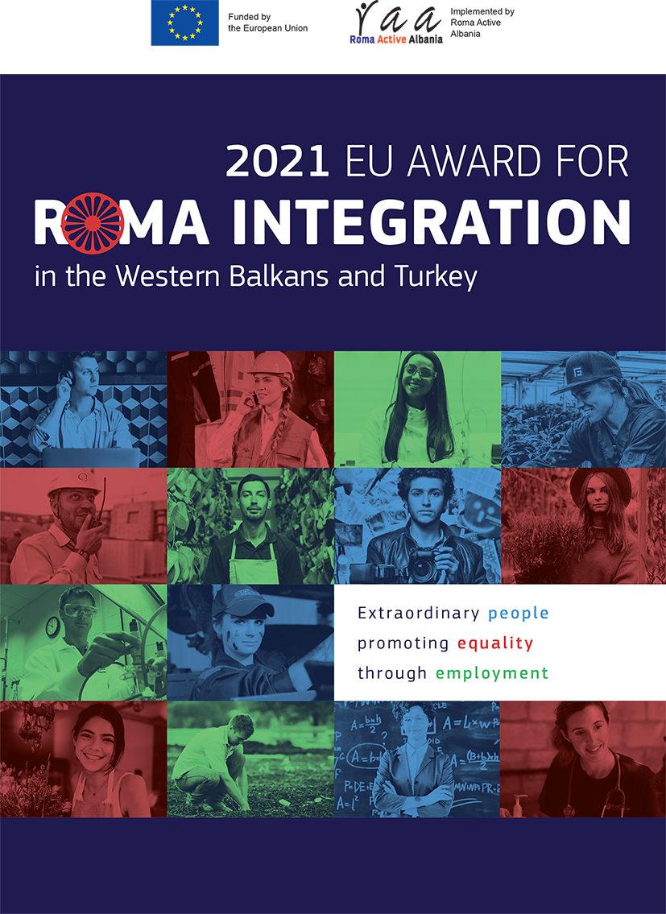
APPLICATION (SELF NOMINATION) FORM
EU Award for Roma Integration in the Western Balkans and Turkey, 2021

For all background information, details on how to apply, and criteria for eligibility and selection, applicants are invited to refer to the ”Rules of contest, and eligibility and selection criteria” on the EU Award for Roma Integration in the Western Balkans and Turkey, 2021

1. Personal information
Full Name of the nominee / name of the institution: | Click here to enter text.
Date of birth / date of establishment: | Click here to enter text.
Place of residence / Place of registration and activity: | Click here to enter text.
Contact information: | Click here to enter text.
Email / website: | Click here to enter text.

Describe the main activity/ies undertaken by you in the last years that resulted in, or have good potential to contribute to, enhanced quantity and/or quality of Roma employment. What was the main impact achieved?

(Please keep in mind that this information can be used for publication).
[Use maximum of 400 words]
2. What is your motivation to apply for this award?
Describe the main factors and reasons for applying for the award. Explain also, in which way you meet the criteria for the award.

[Use maximum of 300 words]

3. Describe the main significant changes that happened in your community, related to any of the following fields;
- Advocacy and lobbying resulting in adoption and implementation of legal frameworks contributing to Employment of Roma.
- Efforts to assist self employed Roma to move from the informal to formal sector
- Training, mentoring resulting in increasing employment for Roma
- Support resulting in improved transfer from education to employment
- Match making between Roma and employees
- Combating antigypsyism in employment
- Specific actions favouring Roma women employment
- Roma Entrepreneurship resulting in Roma employment
- Social Entrepreneurship resulting in Roma employment

[Use maximum of 150 words]

4. What are the main activities in which you have been involved in the last year?
What was the goal of the activities, the objectives that you have met, the people involved and benefited from your actions. Please give information on the number of people involved in the activities, and how the things have changed in the quantity and/or quality of Roma employment, especially in your community.

[Use maximum of 1000 words]

5. What are your plans for the future?

[Use maximum of 300 words]

Supporting documents
Applicantsare invited to provide additional supporting information as available, and encouraged to send documents in electronic version whenever possible. Supporting information may include:
  - Video clips, photographs;
  - publications (leaflets, brochures etc. promoting the initiative/project);
  - links to websites related to the initiative/project (to be mentioned in the application form)
  - media coverage (if any);
  - any other material and proof of the impact of the initiative implemented by the applicant for the prize

Application deadline: 30th of April 2021
Please submit your application at the latest by 30th of April 2021, 23:59 local Time.
Submission of applications shall be via e-mail in the address: Application_EU_Award_2021@raa.al.
The title of the email must contain the initials of the applicant and the country of origin.
Applications, along with the supporting documents, can also be sent by post at the address:
Roma Active Albania - Rr. “YlbereBylykbashi”; P. 25; Shk. 2; Ap. 4; Tirana, Albania
In this case, only the applications received by us within the deadline will be considered. Applications reaching by post later than the set deadline shall not be considered for evaluation.

As it is most commonly used in EU policy documents and discussions, the term "Roma" refers to a variety of groups of people who describe themselves as Roma, Gypsies, Travellers, Manouches, Ashkali, Egyptian, Sinti and other without denying the specificities of these groups.

